A Potent, *in vivo* Active Antimalarial Series Based on a Triazolopyrazine Core: Communal Lead Optimization in an Open Source Malaria Series

Edwin G. Tse,1,2 Alice Motion,2 Maryam Alobaidly,3 Jenya Antonova,4 Nkengafeh Asong,3 Jake Baum,5 Sue Charman,6 Kelechukwu Chukwu,3 Darren J. Creek,7 Michael J. Delves,5 Adelaide S. M. Dennis,8 Vy Duong,3 Korina Eribez,4 Fernando Galvan,3 Mark Gardner,9 Irene Hallyburton,10 Jessica Hauger,3 Daisy J. Kim,3 Kiaran Kirk,8 Dana M. Klug,1 Marat Korsik,2 Adele M. Lehane,8 Kenneth Lowe,3 Kimberly Lowe,3 Tracy T. Ly,3 Thomas S. C. MacDonald,2 María Santos Martínez-Martínez,11 Stephan Meister,4 Ho Leung Ng,12 R. Scott Obach,13 Sabine Ottilie,4 Melanie C. Ridgway,8 Peter J. Rutledge,2 Anthony Sama,14 Christian Scheurer,15,16 Ben F. Sedzro,3 Raman Sharma,13 David G. Smith,17 Chase C. Smith,3 Christopher Southan,18 Anubhav Srivastava,7 Chris Swain,19 Fernando Sánchez-Román Terán,5 Joanna Ubels,2 Sara Viera,11 Gregory S. Walker,13 David Waterson,20 Paul A. Willis,20 Elizabeth A. Winzeler,4 Sergio Wittlin,15,16 Michael Witty20 and Matthew H. Todd1*

1. School of Pharmacy, University College London, London WC1N 1AX, U.K.
2. School of Chemistry, The University of Sydney, NSW 2006, Sydney, Australia
3. School of Pharmacy-Worcester/Manchester, Massachusetts College of Pharmacy and Health Sciences, 19 Foster Street, Worcester, MA 01608, United States
4. Department of Pediatrics, University of California, San Diego, School of Medicine, La Jolla, California 92093, United States
5. Department of Life Sciences, Imperial College London, Exhibition Road, South Kensington, London, SW72AZ, U.K.
6. Centre for Drug Candidate Optimisation, Monash Institute of Pharmaceutical Sciences, Monash University, 381 Royal Parade, Parkville, Victoria 3052, Australia
7. Drug Delivery, Disposition and Dynamics, Monash Institute of Pharmaceutical Sciences, Monash University, Parkville, Melbourne, Victoria 3052, Australia
8. Research School of Biology, Australian National University, Canberra, ACT 2601, Australia
9. AMG Consultants, Discovery Park, Ramsgate Rd, Sandwich, Kent, CT13 9ND, U.K.
10. Drug Discovery Unit, Division of Biological Chemistry and Drug Discovery, School of Life Sciences, University of Dundee, Dundee DD1 5EH, U.K.
11. GlaxoSmithKline R&D, C/ Severo Ochoa, 2, 28760 Tres Cantos, Spain
12. Department of Biochemistry & Molecular Biophysics, Kansas State University, 1711 Claflin Rd., 141 Chalmers Hall. Manhattan, KS 66506, United States
13. Pfizer Inc., Groton, CT 06340, United States
14. [Email: asamawsfl@protonmail.com](mailto:asamawsfl@protonmail.com)
15. Swiss Tropical and Public Health Institute, Socinstrasse 57, 4002 Basel, Switzerland
16. University of Basel, 4002 Basel, Switzerland
17. School of Health and Life Sciences, Federation University, Gippsland Campus, Churchill, VIC 3842, Australia
18. Deanery of Biomedical Sciences, University of Edinburgh, Edinburgh, EH8 9XD, U.K.
19. Cambridge MedChem Consulting, 8 Mangers Lane, Duxford, Cambridge CB22 4RN, U.K.
20. Medicines for Malaria Venture, PO Box 1826, 20 rte de Pre-Bois, 1215 Geneva 15, Switzerland

*[matthew.todd@ucl.ac.uk](mailto:matthew.todd@ucl.ac.uk)

# 

# Abstract

We report an antimalarial series possessing multiple desirable drug-like attributes that encompass high *in vitro* blood stage potency (with EC50 values as low as 17 nM) including against drug-resistant malaria parasite strains, low mammalian cytotoxicity and efficacy in an *in vivo* malaria mouse model. The chemotype is a synthetically tractable triazolopyrazine with representative members accessible in four steps with overall yields ranging from 20-60%. The compounds inhibit the *Pf*ATP4 Na+/H+ ion pump, a target of clinical relevance with no drugs currently approved. Of pharmaceutical industry origins, with further development by a collaboration between the Medicines for Malaria Venture and a contract research organization, the series was transitioned to the public domain where optimization was continued by the Open Source Malaria consortium. This latter phase has included contributions from more than 200 participants ranging from pre-university students to senior scientists in the pharmaceutical industry. The series remains open for further investigation by anyone via a license that does not restrict future commercial development.

# 

# Graphical Abstract

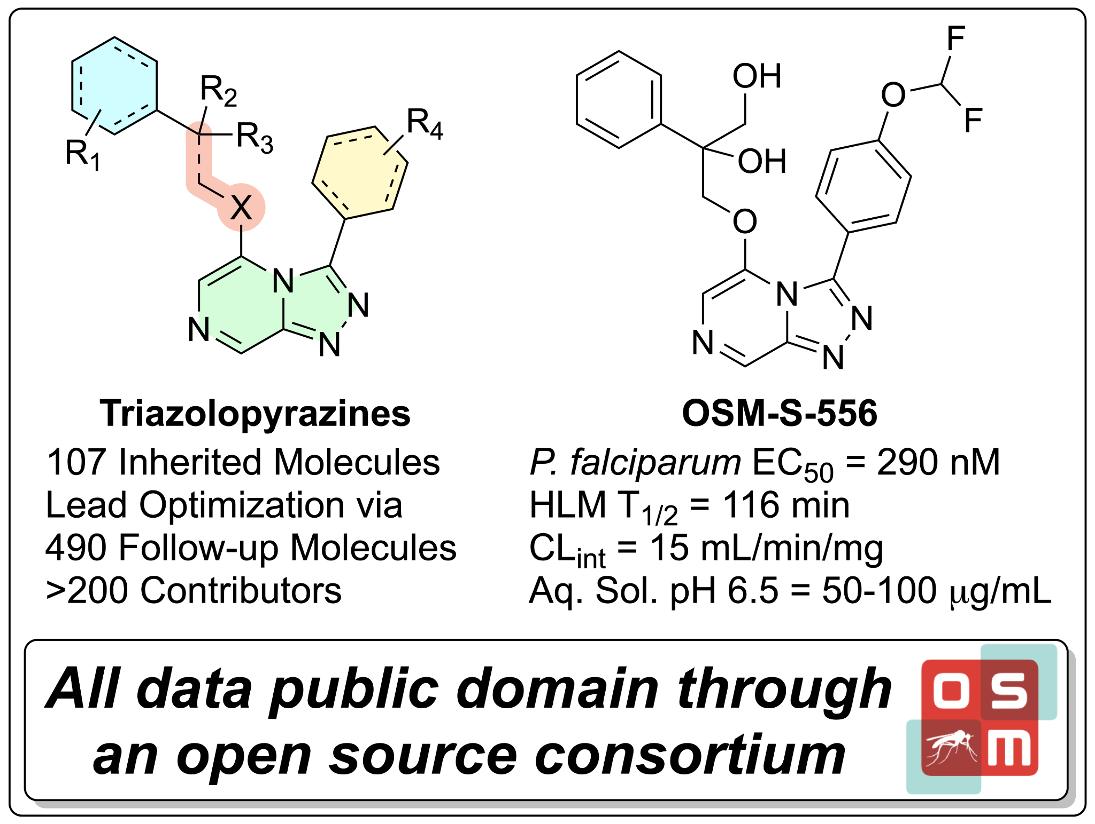

# 

# Introduction

Malaria remains a leading cause of human death annually, with 409,000 fatalities in 2019 out of an estimated 229 million cases. While the number of deaths due to malaria has decreased since the early 2000’s, when both political will and increased funding began to respond in earnest to the disease, increasing populations and other complicating factors have led to a leveling off of decreasing mortality rates. Reductions in malaria mortality and morbidity rates are forecasted to miss their 2020 goals even without taking into consideration the effects of the COVID-19 pandemic.[1](https://sciwheel.com/work/citation?ids=11567870&pre=&suf=&sa=0)Contributing to the problem is growing resistance of the parasite to antimalarial drugs, including the most recently developed artemisinin derivatives.[2,3](https://sciwheel.com/work/citation?ids=149873,3941968&pre=&pre=&suf=&suf=&sa=0,0) In order to counter the evolving drug resistance, there is a need for new antimalarial agents that possess novel mechanisms of action.[4](https://sciwheel.com/work/citation?ids=6776218&pre=&suf=&sa=0)

One approach to addressing the need for the development of novel antimalarial drugs was promulgated by the Medicines for Malaria Venture (MMV). Established in late 1999 and focusing on neglected tropical diseases, MMV created a public-private partnership model that filled the gap between drug discovery efforts in the pharmaceutical industry (return-on-investment driven paradigm) and drug discovery efforts of scientists working on molecular matter that fit a particular target candidate profile.[5](https://sciwheel.com/work/citation?ids=11567871&pre=&suf=&sa=0) As part of this model, MMV partnered with Pfizer in 2009 to undertake a high-throughput screen (HTS) of 160,000 compounds in Pfizer’s chemical library as potential starting points for new antimalarial drugs.[6,7](https://sciwheel.com/work/citation?ids=11567872,11567873&pre=&pre=&suf=&suf=&sa=0,0) From the screening effort, most of the results of which remain unpublished, a unique class of triazolopyrazines emerged as a promising new antimalarial series. Further development by MMV, first in collaboration with Pfizer, and subsequently with a contract research organization (TCG Lifesciences Pvt. Limited), resulted in multiple active compounds, examples of which are shown in **Figure 1A (Supplemental Information File X Poster)**. While potent, **OSM-S-218[1]** and **OSM-S-377** were found to be metabolized rapidly by human and mouse liver microsomes. **OSM-S-272**, however, showed greater stability in the initial microsomal stability assays (HLM 16 μL/min/mg, RLM 70 μL/min/mg) and a promising *in vivo* rat PK profile (*iv* 0.5 mg/kg, po 3 mg/kg, Cl 44 mL/min/kg, Vss 0.9 L/kg, T1/2 0.6 h, and Oral F 16%). This compound was advanced to a mouse efficacy model in which it demonstrated rapid clearance of parasitemia in *P. falciparum* infection with an EC90 of 6.3 mg/kg (**Figure 1B**). In an independent study performed at the Swiss Tropical and Public Health Institute (TPH), at day 7 post-infection, n=2 mice treated with a 4 x 50 mg/kg *per os* dosing regimen of **OSM-S-218** were parasite-free (>99.9% activity) compared to n=4 untreated control mice (see SI) with a parasite detection limit of 1 parasite in 10,000 erythrocytes (i.e., 0.01%).

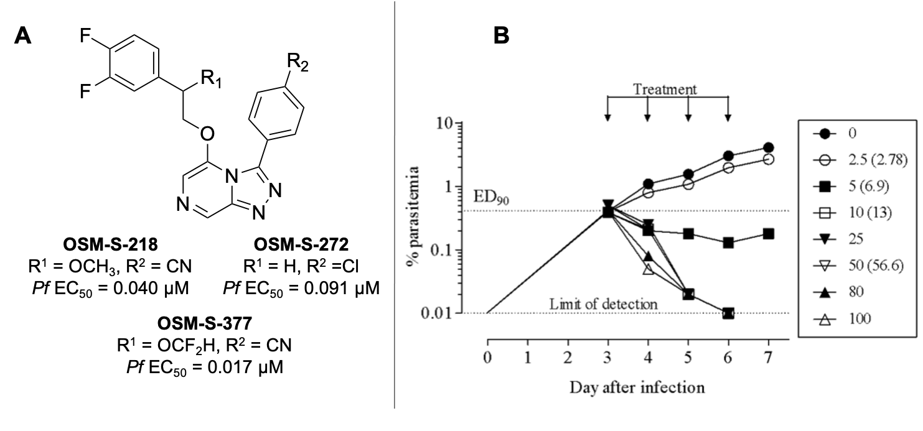

**Figure 1.** A) Example triazolopyrazine antimalarial hits from the MMV HTS of the Pfizer compound library. B) *In vivo* efficacy of **OSM-S-272** against *P. falciparum* growing in peripheral blood of NODscidIL2R𝜸null mouse model. Compound **OSM-S-272** was administered orally, qd for four days at the doses indicated in the legend. Numbers in brackets represent dose (mg/kg) corrected according to quality control of formulation.

Following the initial drug discovery program, MMV provided a summary report that included potency data on just over 100 compounds, along with some early pharmacokinetic and pharmacodynamic data on select compounds, to the Open Source Malaria (OSM) consortium.[8](https://sciwheel.com/work/citation?ids=11567874&pre=&suf=&sa=0) As part of the mission of the OSM, all information was made publicly available in order to jumpstart a lead optimization program aimed at improving the compounds’ solubility (≥100 μM), maintaining potency (EC50 <10 nM) and lowering the rates of metabolic clearance.[9](https://sciwheel.com/work/citation?ids=11588628&pre=&suf=&sa=0) The goal in making the project public was to solicit talent and expertise from a wide variety of sources and to investigate whether an open, unrestricted collaboration could progress the medicinal chemistry efforts during lead optimization in a way that had proven effective as a collaboration mechanism for a previous hit-to-lead project based on a small molecule derived from a screen by GlaxoSmithKline.[10](https://sciwheel.com/work/citation?ids=6684447&pre=&suf=&sa=0) The participatory nature of OSM, in which anyone is free to contribute as the research is proceeding (rather than after it is completed), complements other initiatives centered on the deposition of open data for the research community.[11,12](https://sciwheel.com/work/citation?ids=6221504,1782171&pre=&pre=&suf=&suf=&sa=0,0) As a result of this open source project having many contributors worldwide, varying sources of *in vitro* assays were used, which evaluated the compounds against either the NF54 or 3D7 strains of *P. falciparum*; suitable controls were used throughout to ensure data from different assays (*e.g.*, inherited *vs.* generated data) could be compared. The NF54 strain is sensitive to all known drugs, while 3D7 strain is a clone of the NF54 strain and is known to produce fewer gametocytes in the *in vitro* cultures.[13](https://sciwheel.com/work/citation?ids=11567875&pre=&suf=&sa=0) The ‘potencies’ reported in this communication represent the overall average EC50 values obtained in the *in vitro* parasite growth assays using the aforementioned strains. A complete listing of compound activity against individual *Plasmodium* strains is provided in the Supplemental Information and is maintained live on the OSM compound Master List.[14](https://sciwheel.com/work/citation?ids=11570704&pre=&suf=&sa=0)

The ultimate goal of the present project was to advance the compound development to a point that the chemical matter was attractive enough for funding towards further preclinical research since no “born open” compound (discovered, deposited and developed in the public domain) has ever progressed into a clinical trial. We present here: 1) the combined results to date from the consortium’s work on this series for the treatment of blood stage malaria infections; 2) evidence of the mechanism of action; and 3) suggested next steps.

# Results and Discussion

## Synthesis

The Series 4 triazolopyrazines can, most broadly, be classified into two sub-classes of compounds: those with a heteroatom linker in the 5-position, and those with an amide linker (**Scheme 1**). The synthesis of the former may be achieved by initial displacement of a chlorine atom from 2,6-dichloropyrazine with hydrazine hydrate to give the hydrazine intermediate (**Scheme 1 - Route A**). Condensation with the appropriate aldehyde and subsequent oxidative cyclization using (diacetoxyiodo)benzene affords the cyclized triazolopyrazine core. Final products were obtained upon displacement of the 5-position chlorine atom with an appropriate nucleophile (either synthesized or commercially available). In the case of the amide-linked compounds, the linker was first installed *via* T3P mediated amide coupling with 6-chloropyrazine-2-carboxylic acid and the appropriate amine (**Scheme 1 - Route B**). The subsequent steps to form the triazolopyrazine core were performed in the same manner as for the heteroatom-linked compounds. In both cases, the synthetic procedures used were robust and applicable to multi-gram scale. The synthetic protocols for any compound in this paper may be found in full in the Supplemental Information, which also provides links to the complete synthetic details of each experiment within the publicly available electronic laboratory notebooks (ELNs). A focused subset of Series 4 compounds containing phenyl isosteres has been published elsewhere, as have examples of a *tele*-substitution reaction discovered during the course of this project in which nucleophilic addition in the final step of the synthesis of the heteroatom series was found to take place at the 8-position (**Scheme 1 - Route A**).[15,16](https://sciwheel.com/work/citation?ids=11567877,11567878&pre=&pre=&suf=&suf=&sa=0,0)



**Scheme 1.** General synthetic route to either the 5-substituted heteroatom-linked (**Route A**, Nu− = RO−, RNH−, RS−) and/or amide-linked (**Route B**) triazolopyrazines.

## Structure-Activity Relationships

The following sections present an overview of the key SAR findings and a complete table of analogs tested in the project is contained in the Supplemental Information and is maintained live on the OSM compound Master List.[14](https://sciwheel.com/work/citation?ids=11570704&pre=&suf=&sa=0) The open source nature of the project led to various contributions arising from the community, ranging from suggestions of chemical space to explore through to fully-fledged synthesis and evaluation of analogs in contributor laboratories. Potencies are color-coded according to: <1 uM = green; 1-2.5 uM = orange; >2.5 uM = red.

The importance of maintaining the triazolopyrazine scaffold was established early in the program through exploration of variations in the heterocyclic core and also some limited chain transpositions (**Figure 2**). A modest loss in potency was observed upon the systematic replacement of the core triazole nitrogens with –CH groups (**OSM-S-273** and **OSM-S-274**) as compared to the triazolopyrazine **OSM-S-272**. The imidazopyrazole analog **OSM-S-273** was not pursued further due to its high similarity to a class of antimalarial imidazopyrazoles already reported by Novartis and which possessed a different mechanism of action.[17](https://sciwheel.com/work/citation?ids=11567879&pre=&suf=&sa=0) While not a core modification, any substitution at the 8-position (e.g., **OSM-X-063**) also led to a significant loss in activity.[16](https://sciwheel.com/work/citation?ids=11567878&pre=&suf=&sa=0) Oxidation of the pyrazine nitrogen to the *N*-oxide **OSM-X-054** or the pyrazine ring itself to the triaziolopyrazin-8-one **OSM-X-055** also resulted in loss of activity. Transposition of the ether side chain from the 5-position to the 6-position (**OSM-X-001**) was well tolerated and even resulted in a boost in activity. Variation of analog **OSM-X-001** was not pursued further due to synthetic throughput limitations, but it is recognized that this may be an opportunity for a future route of optimization. Transposition of the pyrazine nitrogen of **OSM-X-001** to give the triazolopyridazine **OSM-X-061** led to a large reduction in potency. Both of the 6-position ether analogs distantly resembled several series of antimalarial imidazopyridazines and pyrazolopyridines reported in the literature and which are likely to have a different mechanism of action.[18,19](https://sciwheel.com/work/citation?ids=11567880,2700226&pre=&pre=&suf=&suf=&sa=0,0) For these reasons, it was decided that further SAR exploration would maintain the triazolopyrazine core with variations being made on the pendant 3- and 5-positions, with the primary goal being to increase potency.



**Figure 2.** Activity profile resulting from modifications to the triazolopyrazine core of the Series 4 scaffold.

The identity and length of the linker unit between the 5-position aryl group and the triazolopyrazine core proved influential on activity (**Figure 3**). An ether linker with two methylene units between it and the pendant phenyl ring (example **OSM-S-369**) was ideal, with longer or shorter chain lengths resulting in reduced activity.[15](https://sciwheel.com/work/citation?ids=11567877&pre=&suf=&sa=0) A significant loss in potency was seen upon replacement of the ether linker with a thioether (**OSM-S-571**), sulfone (**OSM-S-364**), sulfoxide (**OSM-S-365**), or amine (**OSM-S-368**) linker. Interestingly, exchanging the heteroatom with a methylene group (**OSM-X-011**) was well tolerated and maintained activity; however, this change was accompanied by an increase in cLogP and so its further exploration was deprioritized.

The corresponding amide series showed activities comparable to the ether series. Aniline-derived amides with *meta-*substitution (**OSM-S-202**) showed superior activity over compounds containing substitution at the *ortho*- or *para*- positions (see Supplemental Information). In an effort to avoid the inclusion of a potentially undesirable aniline moiety, a related trifluoromethyl-pyridyl derivative (**OSM-S-175**) was synthesized and found to be nearly equipotent. All other unsubstituted pyridyl analogs however, were found to be inactive (see Supplemental Information). Benzylamine-derived amides were also synthesized and again followed a similar activity profile to the aniline amides with the *ortho-*substitution being favored (**OSM-S-176**). Methylation of the amide nitrogen (**OSM-X-036**) caused an approximate 4-fold loss in potency. The reverse amide **OSM-W-006** was also found to be inactive. A variety of other aliphatic amides were assessed but none was discovered to have sub-micromolar potency against *P. falciparum*. While several amide compounds did show promising activity and further exploration of the SAR was warranted, early exploration of hERG binding suggested the amide linker introduced a liability (see **Table 1**). The amide-linked **OSM-S-175** was found to possess a hERG pIC50 of 5.60, and upon further investigation, a number of additional amide-linked compounds were also found to provide higher levels of hERG binding than the ether-linked compounds.[20](https://sciwheel.com/work/citation?ids=2699256&pre=&suf=&sa=0) As a result, the amide sub-series was deprioritized.



**Figure 3.** Survey of modifications to the linker region between the triazolopyrazine core and the northwest pendant functionality.

As a general trend (**Figure 4**) throughout the series as a whole, replacement of the northwest pendant phenyl ring with a 3,4-difluorophenyl substitution pattern (**OSM-S-272** and **OSM-S-260**) resulted in increased activity compared to the unsubstituted (**OSM-S-293** and **OSM-S-369** respectively) or monosubstituted (**OSM-W-010**) analogs. *Meta*-substitution alone was well tolerated as seen with the methoxy analog (**OSM-S-383**), while *para*-substitution was much less favorable with this functional group (**OSM-S-384**). While thiophene **OSM-S-608** did demonstrate modest activity, an extensive search of other heteroaromatic replacements for the northwest phenyl ring was not undertaken and may represent a future area of exploration. As part of a separate investigation, compounds in which the pendant phenyl ring was replaced with saturated heterocycles and hydrocarbon cages were made in an attempt to improve solubility and metabolic stability *via* deplanarization and dearomatization. Such changes generally resulted in reduced efficacy, with a small number of notable exceptions (for example the cubane derivative **OSM-S-371** and the carborane **OSM-S-418** shown in Table 1).[15](https://sciwheel.com/work/citation?ids=11567877&pre=&suf=&sa=0)



**Figure 4.** Survey of modifications to the northwest region of the scaffold linked to the triazolopyrazine core *via* an ethylene-ether linkage.

The triazole 3-position substituent (northeast pendant phenyl - **Figure 5**) was found to be highly sensitive to substitution. Generally, alkyl, cyano, nitro, or halogenated substituents at the *para-* position (**OSM-S-260**, **OSM-S-272**, **OSM-W-009**, **OSM-S-550**, **OSM-S-585**) resulted in analogs that retained sub-micromolar potency. Carboxylic acids (**OSM-S-551**, **OSM-S-552**), amides (**OSM-S-494**, **OSM-S-495**) and sulfonamide (**OSM-S-506**) significantly reduced activity or rendered the compounds inactive. A primary aniline at the *meta-* position (**OSM-S-549**) gave weak activity that was improved by the addition of a halogen at the *para-* position (**OSM-S-548** and **OSM-S-585**). The chloro-aniline **OSM-S-548** was one of the most potent compounds in this series; however, acetylation or methylation of the amine caused a loss of activity (see SI). Limited attempts to find a bioisosteric replacement for the aniline generally resulted in compounds that were less active (**OSM-S-525**, **OSM-S-546** and additional analogs detailed in the Supplemental Information). While the chloro-aniline **OSM-S-548** was intriguing, due to the lack of additional metabolic safety data, it was deprioritized owing to potential concerns that the aniline would be a liability.[21–23](https://sciwheel.com/work/citation?ids=1863911,6826507,11567881&pre=&pre=&pre=&suf=&suf=&suf=&sa=0,0,0) Further investigation into the SAR around **OSM-S-548** seems to be warranted however, especially if it can be established that the chloro-aniline does not lead to a reactive metabolite or if modifications can be made to mitigate this possibility.[24](https://sciwheel.com/work/citation?ids=11188279&pre=&suf=&sa=0)

As mentioned earlier in the discussion of the modification to the triazolopyrazine core, despite evidence from related scaffolds that a *para*-methylsulfone substituent on the phenyl ring would result in highly potent compounds, analog **OSM-W-005** was found to be inactive in this series.[18,19](https://sciwheel.com/work/citation?ids=11567880,2700226&pre=&pre=&suf=&suf=&sa=0,0) In further SAR exploration, and in keeping with the goal of improving metabolic clearance and solubility, saturated and unsaturated heterocycles were also assayed as possible replacements to the substituted northeast phenyl ring. Although these compounds usually resulted in lower logP values, they were generally either less active or inactive (**Figure 5**). All logP values were calculated using the open-source program DataWarrior.[25](https://sciwheel.com/work/citation?ids=2341255&pre=&suf=&sa=0)



**Figure 5.** Survey of modifications to the northeast region of the series linked to the triazolopyrazine core at the 3-position.

Finally, analogs substituted at the benzylic position were designed to mitigate a potential metabolic liability at this position and improve solubility. These modifications were generally beneficial, with many compounds showing sub-micromolar activity. The most notable compounds containing benzylic substitutions are the alcohol-(**OSM-S-390**, **OSM-X-004**, **OSM-S-560**, **OSM-S-279**, **OSM-S-353**, and **OSM-S-541/OSM-S-556**), fluoro- (**OSM-X-003** and **OSM-X-006**) and dimethylamine-containing (**OSM-S-389**) analogs, all of which showed improved activity over the compounds with the unsubstituted ethylene linker (**Figure 6**).

Additionally, the installation of alcoholic functionality translated to improved clogP values, and this modification was pursued further. The benzylic position in the phenethyl side-chain was found to be prone to metabolic oxidation (see next section on Metabolism and Solubility), so several compounds having di-substitution at this position were made (**Figure 6**). Disappointingly, di-substitution tended to lower the potency over mono-substitution. Of particular note are the two diols **OSM-S-560** and **OSM-S-556**, which showed reduced potency as compared to their singly hydroxylated counterparts **OSM-S-390 / OSM-S-381** and **OSM-S-279 / OSM-S-353** respectively. Furthermore, diol **OSM-S-556** was first identified as a major metabolite from a biosynthetic metabolism experiment and was initially reported to have an IC50 against *P. falciparum* of 9 nM. Upon resynthesis, **OSM-S-556** was instead found to be much less potent with a mean potency of 285 nM (**Figure 7**). It is unknown if a single enantiomer was formed during the biosynthetic assay and this discrepancy in activity will need to be further explored. Methyl substitution at the benzyl position was tolerated and allowed potency to be maintained (**OSM-X-004**, **OSM-X-006** and **OSM-S-607**). Also of note, modifications that were clearly detrimental to potency were the installation of a carboxylic acid (**OSM-S-515**) at the benzyl position, oxidation of the benzyl position to the ketone (**OSM-S-392** and **OSM-S-400**), or bis-hydroxymethylene substitution **OSM-S-609**. Ultimately, while synthetically challenging, the benzylic position has been identified as a site that can potentially be leveraged to provide compounds that offer a balance between potency, solubility and metabolic stability. Efforts to further modify the benzylic position are discussed later in the manuscript under future directions.



**Figure 6.** Survey of modifications to the benzylic position of the ether-linked analogs.

In summary, a number of key motifs are required to maintain activity. The triazolopyrazine core is essential for activity with any modification resulting in a loss against *P. falciparum*. A pendant aromatic ring at the 5-position of the core is required for activity, with the 3,4-difluoro being the preferred substitution pattern. The linker tolerates a number of modifications, with primary alcohols at the benzylic position providing an improvement in both potency and clogP. *Para*-substituted aromatic rings are most beneficial for activity at the 3-position of the triazolopyrazine core.

## Metabolism, Solubility and Safety

A number of key compounds from the SAR investigations were evaluated for their metabolic and physicochemical properties, along with hERG activity and cytotoxicity (**Table 1**). None of the compounds tested showed significant hERG activity (a safety margin of 30-fold between hERG and *P. falciparum* IC50 was deemed safe *in vitro*) and cytotoxicity was found to generally be low (**Tables S1 and S2**). Many of these compounds showed improved clearance and solubility over one of the initial Series 4 compounds **OSM-S-369**, showing that it is potentially possible to meet the MMV PK/PD progression criteria in this series.[26](https://sciwheel.com/work/citation?ids=11567889&pre=&suf=&sa=0) In particular, the carboxylic acid **OSM-S-515** displayed reduced clearance and longer half-life, but was inactive against *P. falciparum*. As indicated in the previous discussion of the SAR of the benzylic position, compounds containing a benzylic alcohol (**OSM-S-279**, **OSM-S-390**, and **OSM-S-353**) are promising not only due to their potency, but their early pharmacokinetic profile. The majority of compounds had modest solubility (12 - 50 ug/mL) but increasing the lipophilicity of the ether substituent **OSM-S-371** and **OSM-S-418** had a significant negative impact on solubility.



|  |  |  |  |  |  |  |  |
| --- | --- | --- | --- | --- | --- | --- | --- |
| ***Compound*** | ***P. falciparum EC50 (uM)*** | ***CLint (uL/min/mg)*** | | ***T1/2 (min)*** | | ***Solubility pH 6.5 (ug/mL)*** | ***hERG***  ***pIC50 (uM)*** |
| ***HLM*** | ***Rodent LM*** | ***HLM*** | ***Rodent LM*** |
| **OSM-S-353** | 0.10 | 49 | 361a | 35 | 5a | 12.5 - 25 | 4.7 |
| **OSM-S-218\*** | 0.15 | 47 | 159a | 37 | 11a | 12.5 - 25 | 5.2 |
| **OSM-S-202** | 0.21 | 72 | 290b | 13.6 | 6b | <2.5 (pH 7.4) | 4.9 |
| **OSM-S-201** | 4.2 | 114 | 166a | 15 | 10a | 12.5 - 25 | 5.1 |
| **OSM-S-515** | 3.9 | 7 | 7a | 255 | 255a | 25 - 50 | 5.0 |
| **OSM-S-366** | 0.92 | 71 | 132a | 24 | 13a | 3.1 - 6.3 | 4.5 |
| **OSM-S-371** | 0.37 | 197 | 573a | 9 | 3a | <1.6 | 5.4 |
| **OSM-S-418** | 0.050 | 249 | 866a | 7 | 2a | <1.6 | 5.4 |
| **OSM-S-272** | 0.091 | 33 | 193a | 53 | 9a | 3.1-6.3 | *nd* |

**Table 1**. Clearance, solubility and hERG data for selected analogs. aMouse liver microsomes. bRat liver microsomes. *nd* = Not determined. *Compound **OSM-S-218** was the racemic variant of the originally inherited compound.

Several compounds were selected and investigated in a late-stage biofunctionalization experiment using human liver microsomes (**Fig. 7**). The compounds were incubated with human liver microsomes along with a standard at known concentration. Following the incubation period, the metabolites were isolated *via* HPLC and then characterized by NMR analysis. The isolated metabolites were then assayed against *P. falciparum*to determine their growth-inhibitory activity.[27](https://sciwheel.com/work/citation?ids=11567882&pre=&suf=&sa=0) The metabolites generated from the representative amide compounds (**OSM-S-367** and **OSM-S-175)** were found to be oxidized on the nitrogen heterocycles, both of which led to reduced efficacy *in vitro*. Metabolism of the compound possessing a benzylic methoxy group (**OSM-S-218**) led to the observation of the benzyl alcohol metabolite and then ultimately the less desirable benzylic ketone product. As described previously, the metabolite resulting from oxidation of compound **OSM-S-353** was initially ascribed the identifier **OSM-S-541**. The identified metabolite was immediately assayed and found to possess increased potency as compared to the parent compound. Compound **OSM-S-541** was first thought to have been oxidized on the northwest pendant phenyl ring to give a phenolic product. The promising activity of metabolite **OSM-S-541** rapidly initiated the compound's independent synthesis for retesting. It was immediately apparent following synthesis of the phenol analog of **OSM-S-218** that it did not match the metabolite **OSM-S-541**. The NMR data for the metabolite was re-analyzed and the correct structure determination of the product resulting from benzylic oxidation was determined. The structure was then confirmed following independent synthesis and redesignated **OSM-S-556**. While the structure of the metabolite was confirmed absolutely, the discrepancy between the initial activity during the biofunctionalization assay and subsequent re-testing has not been resolved. As mentioned previously in the section on the SAR of the benzylic position, it is believed that optimization of the substitution on this portion of the linker may be the key to compounds that balance potency and metabolic stability. Using the knowledge gained from the SAR and metabolic studies, future work in this area is outlined later in the discussion section of the manuscript.



**Figure 7.** Compounds of interest and isolated metabolites, with major structural changes highlighted in blue.

Oxidation of the triazolopyrazine core was consistently observed in addition to side chain-specific transformations such as *O*-dealkylation of ethers or benzylic oxidation. In order to understand how the triazolopyrazines were being metabolized, it was investigated whether this oxidation was due to traditional CYP enzymes or whether aldehyde oxidases (AOs) were involved. The half-life of select Series 4 compounds were studied in human liver cytosol versus that of known AO substrates. It was observed that compounds containing benzylic alcohols, such as **OSM-S-279** or **OSM-S-353**, were relatively stable to AO metabolism, while amides were metabolized rapidly. Based on these studies, and combined with the hERG data (**Table 1**), the amide side chains were deprioritized despite their initially promising clearance and solubility.

## Mechanism of Action

Preliminary investigation of the mechanism of action of Series 4 compounds points to the *P. falciparum* P-type ATPase 4 (*Pf*ATP4) as the target. *Pf*ATP4 is a Na+ efflux transporter that maintains Na+ homeostasis in the malaria parasite. The efflux of Na+ is accompanied by a corresponding influx of H+ equivalents. Inhibition of *Pf*ATP4 results in an accumulation of Na+ within the parasite, an alkalinization of the parasite cytosol, parasite swelling and, ultimately, parasite death.[28–30](https://sciwheel.com/work/citation?ids=1774980,4522029,11567883&pre=&pre=&pre=&suf=&suf=&suf=&sa=0,0,0) A panel of Series 4 triazolopyrazines were screened using fluorescence-based assays for their effect on the cytosolic [Na+] and pH in mature asexual-stage *P. falciparum* 3D7 trophozoites that were isolated from their host cells by permeabilization of the host-cell membrane. The known *Pf*ATP4 inhibitor, cipargamin, was used as a positive control. The *Pf*ATP4-inhibition ability of each of the compounds tested was classified as either *Yes*, *Moderate* or *No* (**Figures S1, S2 and S3**). A strong correlation was observed, consistent with the more potent inhibitors inducing greater increases in both the cytosolic Na+ concentration and pH than their less potent counterparts (**Figure 8**).

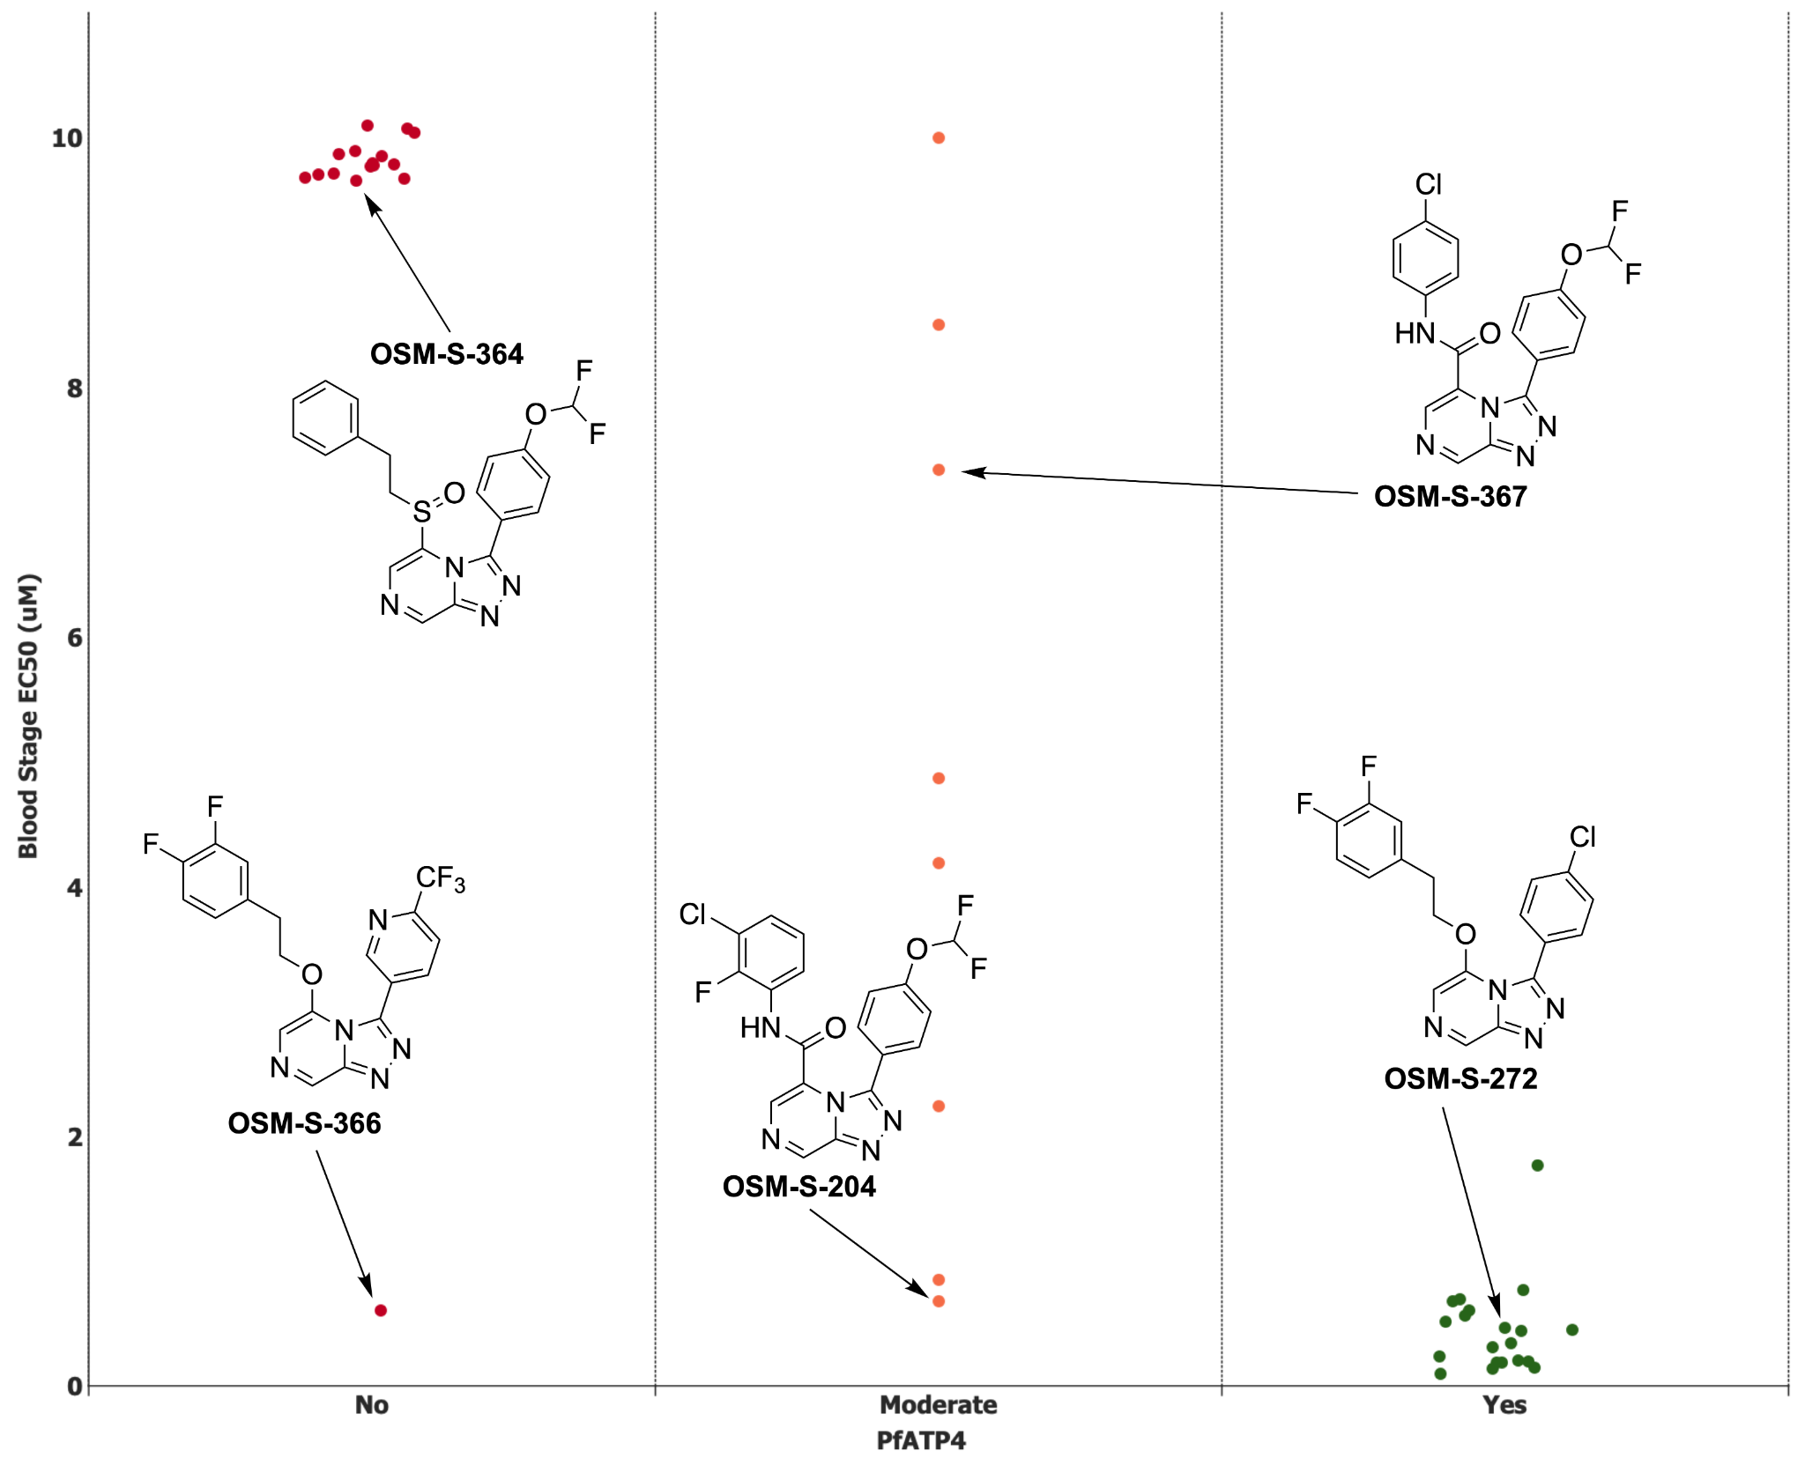

**Figure 8.** Correlation of parasite growth-inhibition activity with inhibition of *Pf*ATP4, as indicated by perturbation of the parasite’s cytosolic [Na+] ([Na+]cyt) and pH. ***Yes***: the compound gave rise to an increase in [Na+]cyt and pHcyt that was similar in magnitude to that induced by 50 nM cipargamin (a validated *Pf*ATP4 inhibitor) when tested at 1 µM. ***Moderate***: the compound gave rise to an increase in [Na+]cyt and pHcyt when tested at 1 µM and/or 5 µM, with its effect at 1 µM being lower in magnitude than that of 50 nM cipargamin. ***No***: the compound did not affect either [Na+]cyt or pHcyt when tested at 1 µM or 5 µM.

A diverse range of antimalarial chemotypes has been implicated as having a mechanism of action based on inhibition of *Pf*ATP4.[31,32](https://sciwheel.com/work/citation?ids=11567884,11567885&pre=&pre=&suf=&suf=&sa=0,0) Several of the Series 4 compounds were tested for their efficacy against *Pf*ATP4-mutant lines of *P. falciparum* that had been generated previously by exposing (Dd2) parasites to *Pf*ATP4-associated compounds. These lines are resistant to a range of *Pf*ATP4 associated compounds and had reduced susceptibility to the Series 4 compounds tested here. This ‘cross-resistance’ is consistent with the Series 4 compounds sharing their mechanism of action with the *Pf*ATP4-associated compounds characterised previously (**Figure S4**).[31,33](https://sciwheel.com/work/citation?ids=11567884,11567886&pre=&pre=&suf=&suf=&sa=0,0)

The mode of action was further investigated using an established, unbiased metabolomics approach for studying antimalarials.[34](https://sciwheel.com/work/citation?ids=6684383&pre=&suf=&sa=0) The active compound **OSM-S-218** (*P. fal* EC50 = 0.04 µM), and the inactive analogue **OSM-S-291** (*P. fal* EC50 >5 µM) were used under sublethal conditions against trophozoite stage *P. falciparum* parasites to induce specific metabolic perturbations, alongside known antimalarial reference compounds atovaquone (**ATV**), chloroquine (**CQ**) and dihydroartemisinin (**DHA**); and three antiplasmodial *Pf*ATP4 inhibitors (**Figure SX**).[34](https://sciwheel.com/work/citation?ids=6684383&pre=&suf=&sa=0) Metabolomics analysis of cell pellets and spent media allowed reproducible coverage of a range of metabolic pathways, with the most significant **OSM-S-218** induced perturbations observed within peptide, lipid and energy metabolism (**Figure SX**). A multivariate sparse-PLSDA analysis of cell pellet samples revealed that the primary metabolic impact of **OSM-S-218** treatment was consistent with the perturbations observed for the three reference *Pf*ATP4 inhibitors, and these samples clustered distinctly from the other reference compounds with different mechanisms of action (**Fig. 9A** and **Fig SX**).[35](https://sciwheel.com/work/citation?ids=1510331&pre=&suf=&sa=0) Cultures incubated with the inactive analogue (**OSM-S-291**) clustered with the untreated controls, confirming the lack of impact on parasite biology.

The metabolite features responsible for the distribution of samples across the first sPLSDA component were primarily peptides derived from haemoglobin digestion, which were depleted following treatment with the *Pf*ATP4 inhibitors, DHA, and to a lesser extent, chloroquine (**Figure 9B**). These results are consistent with previous data, and suggest that inhibition of digestive vacuole function is a major impact of each of these classes of antimalarials.[34](https://sciwheel.com/work/citation?ids=6684383&pre=&suf=&sa=0) Differentiation between *Pf*ATP4 inhibitors (including **OSM-S-218**) and the known digestive vacuole-targeting drugs (chloroquine and DHA) was observed in the second sPLSDA component, which included three lysophosphatidylserines (lysoPS) in the top five metabolites contributing to this component (**Figure 9C**). Increased levels of lysoPS were observed in cultures treated with *Pf*ATP4 inhibitors (including OSM-S-313), whereas levels of these lipids were generally depleted following treatment with the digestive vacuole-targeting drugs Previous studies of *Pf*ATP4 inhibitor **(+)-SJ733** revealed enhanced PS exposure in the outer membrane leaflet of infected erythrocytes.[36](https://sciwheel.com/work/citation?ids=3416420&pre=&suf=&sa=0) As PS exposure is a marker of eryptosis, a cell death mechanism associated with increased activity of phospholipase A2, the enzyme responsible for lysoPS production, it is likely that the observed perturbation to PS metabolism is associated with the induction of eryptosis.

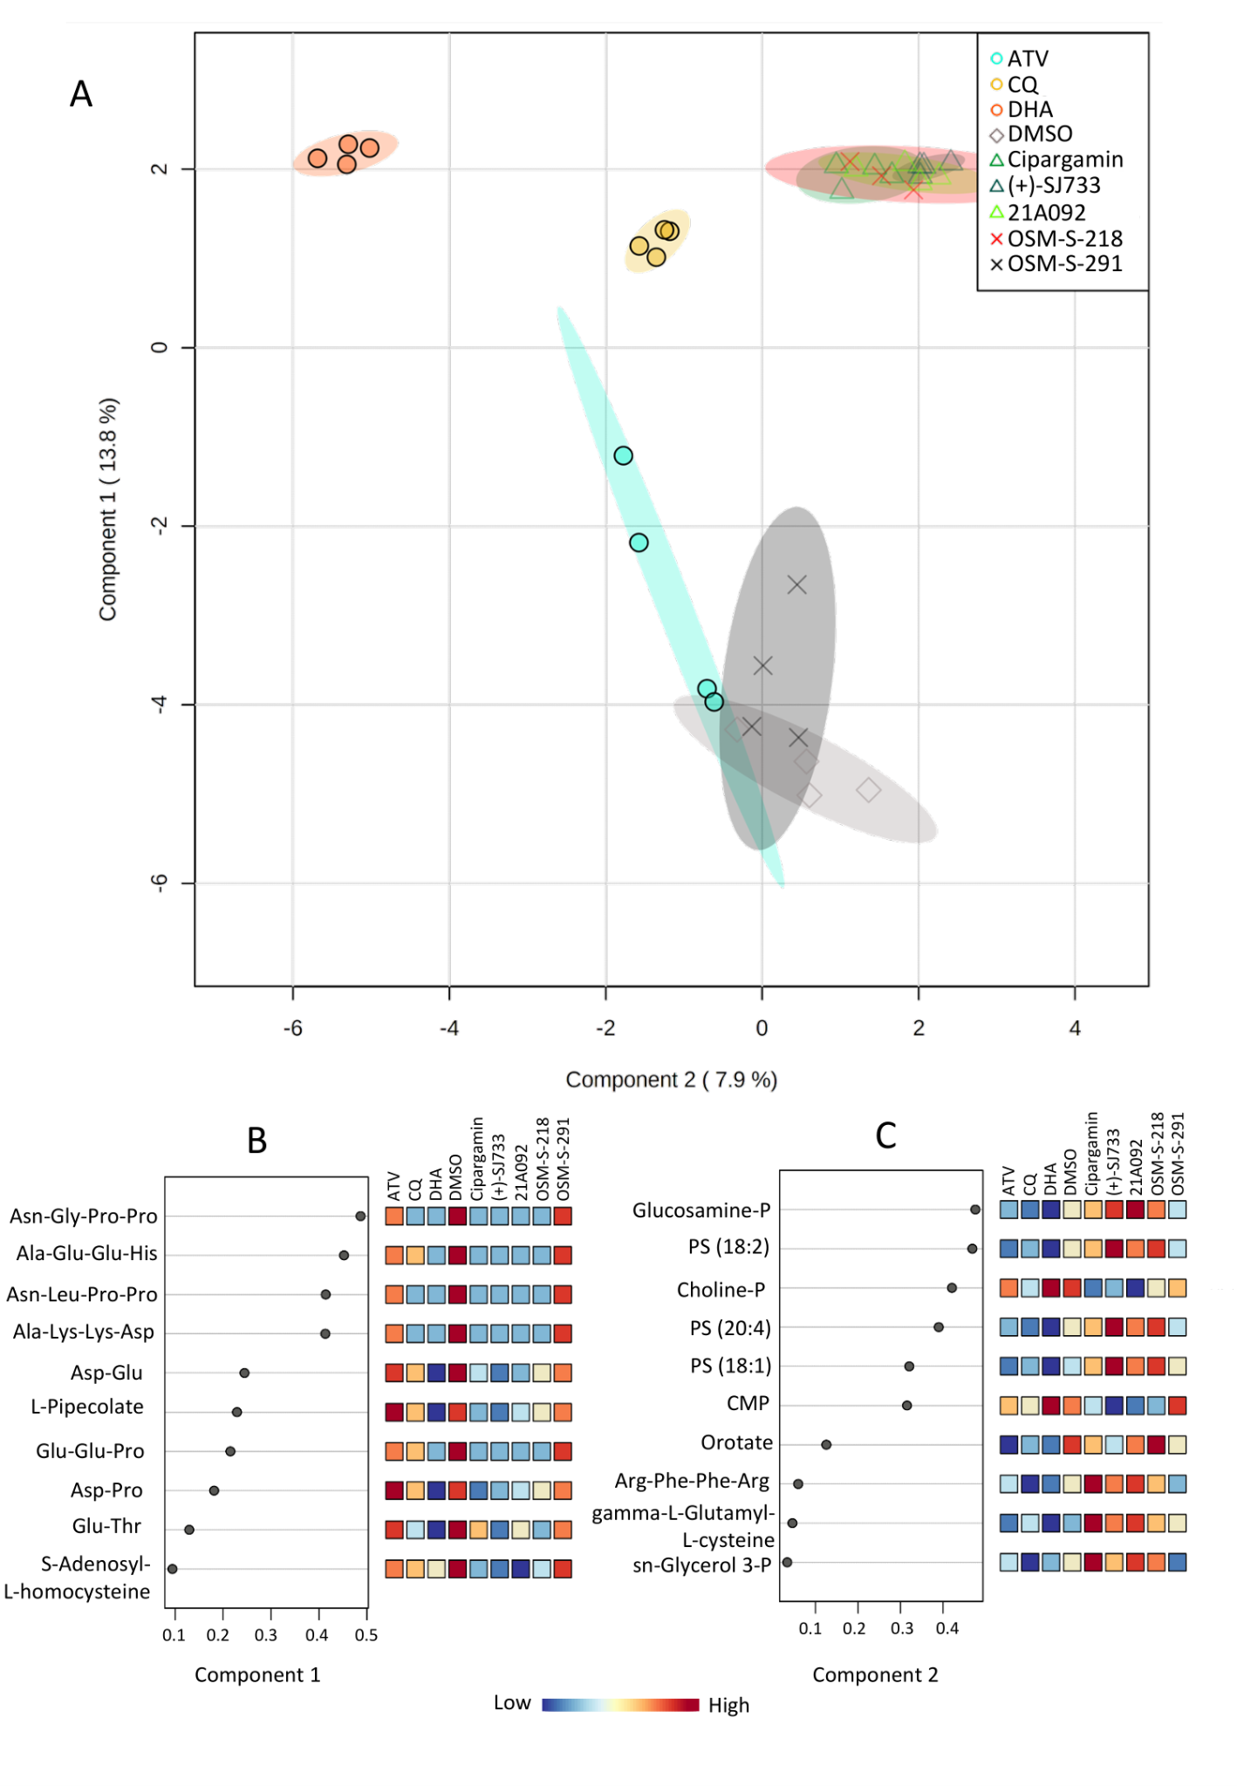

**Figure 9.** (A) Multivariate sparse-PLSDA analysis of levels of all putatively identified metabolites from *P. falciparum*-infected red blood cell pellets treated with OSM-S-218, OSM-S-291, dihydroartemisinin (DHA), chloroquine (CQ), atovaquone (ATV), *Pf*ATP4 inhibitors (Cipargamin, 21A092 and (+)-SJ733) and vehicle control (DMSO). (B/C) Sparse-PLSDA loadings of metabolite features responsible for the distribution of sample groups across components 1 (B) and 2 (C) in panel A and their mean relative abundance. Abbreviations: PS: phosphatidylserine, CMP: cytidine monophosphate, AMP: adenosine monophosphate.

Finally, the potential binding mode of Series 4 compounds to *Pf*ATP4 was investigated. An experimentally-determined crystal structure for *Pf*ATP4 has not yet been determined, and this has hindered attempts at rational drug design and indeed rationalization of the varied chemotypes sharing the *Pf*ATP4-inhibition phenotype. **OSM-S-377**, the most potent compound in the series, was docked into a homology model of PfATP4 built from the crystal structure of the rabbit SERCA calcium pump ATPase 1 (PDB 2DQS) using Yasara and the Yasara2 knowledge-based force field.[37](https://sciwheel.com/work/citation?ids=1607413&pre=&suf=&sa=0) **OSM-S-377** was docked against the entire surface of *Pf*ATP4 using Smina.[38](https://sciwheel.com/work/citation?ids=3468960&pre=&suf=&sa=0) The highest scoring binding site matches the modeled binding site of known *Pf*ATP4 inhibitor **(+)-SJ733**.[36](https://sciwheel.com/work/citation?ids=3416420&pre=&suf=&sa=0) The site also corresponds to the binding site of phosphatidylethanolamine in the crystal structure of rabbit SERCA ATPase 1. The docked binding mode demonstrates the shape preference of the Series 4 compounds. The pocket has mixed hydrophobic/hydrophilic nature that provides favorable hydrogen bonds with the nitrogen-rich **OSM-S-377** (**Figure 10**). The pose supports many observed SAR trends, such as intolerance for extension at the triazolopyrazine 8-position due to clashing with *Pf*ATP4 L347, favorability of a polar tail at the northeast pendant phenyl due to hydrogen bonding with N207, and favorability of an extended hydrophobic northwest pendant phenyl ring. These binding poses were additionally used as the basis of a competition to develop predictive models for active compounds. A range of approaches were taken, leading to the design of novel chemical matter with activity in the blood stage potency assay; improving predictive and generative models is currently one of the open threads of the present project towards further lead optimization.[39](https://sciwheel.com/work/citation?ids=11567887&pre=&suf=&sa=0)

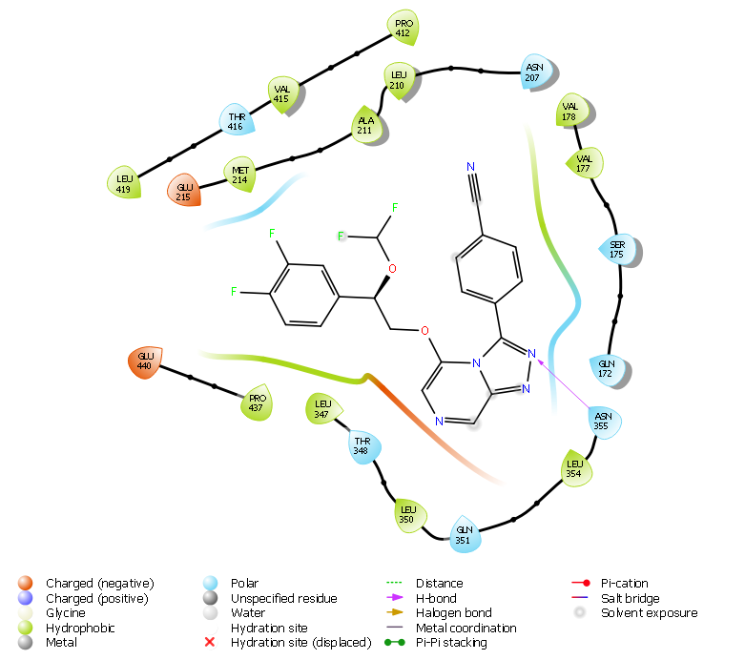

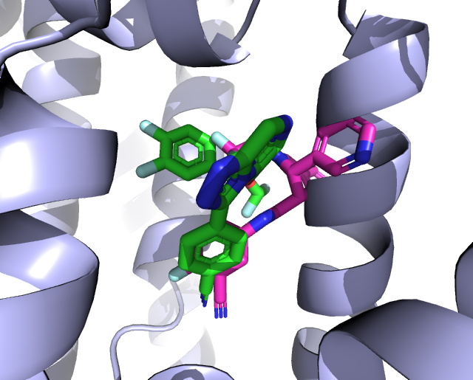

**Figure 10.** A) Docked binding mode of **OSM-S-377** (green) superimposed with the previously published docked pose of SJ733 (maroon) in a homology model of *Pf*ATP4, and B) binding pocket interactions between the homology model and **OSM-S-377**.[36](https://sciwheel.com/work/citation?ids=3416420&pre=&suf=&sa=0)

## Activity vs Other Life Cycle Stages and Strains

Although the bloodstream stage of *Plasmodium* infection is responsible for symptomatic malaria, liver stage infection is an attractive target for the development of a prophylactic agent.[40](https://sciwheel.com/work/citation?ids=677473&pre=&suf=&sa=0) Liver stage potency was evaluated for two compounds (**OSM-S-218** and **OSM-S-175**), which revealed low levels of activity despite the high blood stage potency (**Fig. 11**). It is possible that the weak liver stage activity arises from one of the enantiomers, but due to the low activity observed, this was not pursued further. The low activity clearly distinguishes Series 4 from a structurally similar imidazopyrazine series discovered by Novartis that possesses activity against all liver stages in several *Plasmodium* species.[41](https://sciwheel.com/work/citation?ids=123441&pre=&suf=&sa=0) The two series are believed to possess two distinct mechanisms of action (inhibition of *Pf*ATP4 vs. PI4K).[42](https://sciwheel.com/work/citation?ids=11567888&pre=&suf=&sa=0)

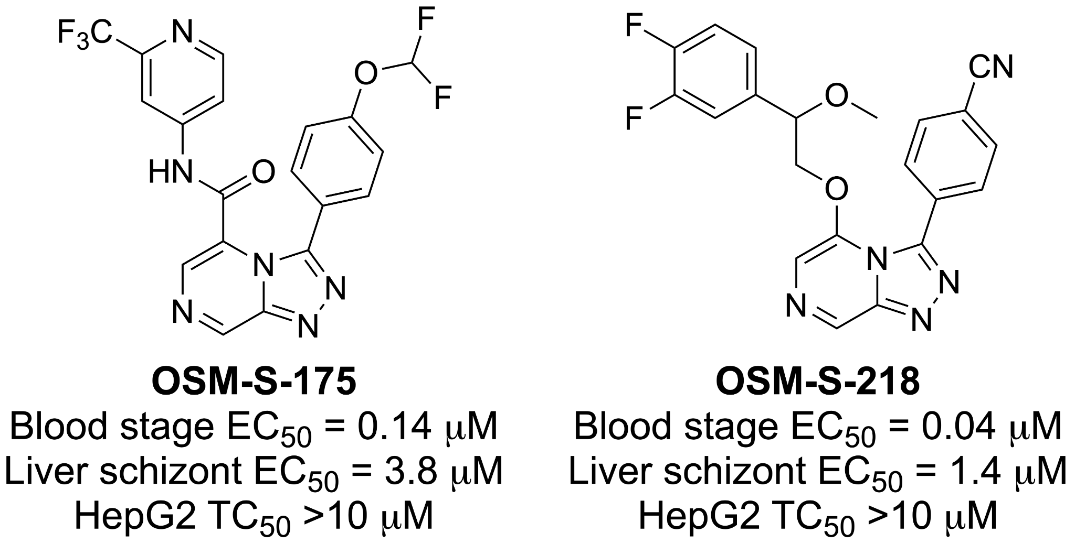

**Figure 11**. Results of liver stage screening.

The gametocyte life-cycle stage of *Plasmodium* is responsible for mediating transmission from an infected human host back to the mosquito vector.[43](https://sciwheel.com/work/citation?ids=5362204&pre=&suf=&sa=0) Compounds that are active against gametocytes in addition to asexual life cycle stages are desirable as treatments and transmission-blocking agents. A selection of Series 4 compounds was assessed for anti-gametocyte activity. While gametocidal activity has been seen for some,[29,44](https://sciwheel.com/work/citation?ids=4522029,3416431&pre=&pre=&suf=&suf=&sa=0,0) but not all compounds thought to inhibit *Pf*ATP4, the data for Series 4 showed that the asexual-active active compounds were either only weakly active or had no inhibitory activity against male gamete formation (**Table SX Delves**).[12](https://sciwheel.com/work/citation?ids=1782171&pre=&suf=&sa=0)

A representative compound (**OSM-S-218**) was found to exhibit unchanged potency (i.e., no cross resistance) against several drug-resistant parasite lines (Dd2, NF54, K1, 7G8, TM90C2B, Cam3.I) (**Table SX**).

## Evaluation against Other Pathogens

Select Series 4 compounds were screened by the Community for Open Antimicrobial Drug Discovery (CO-ADD) against the ESKAPE pathogens *E. coli*, *S. aureus* (MRSA), *K. pneumoniae*, *A. baumannii*, and *P. aeruginosa*, and the fungi *C. neoformans* and C*. albicans*.[45](https://sciwheel.com/work/citation?ids=57307&pre=&suf=&sa=0) As is perhaps expected for compounds with a suspected mechanism of action involving *Pf*ATP4, no compounds screened showed >40% growth inhibition in a single-concentration assay (32 μg/mL) against the ESKAPE pathogens (**Table SX CO-ADD**).

# 

# Conclusions

# 

We have described the lead optimization of a small molecule antiplasmodium series with the potential for the treatment of blood stage malaria infection. Besides demonstrated *in vivo* efficacy in a mouse model of infection, the series of compounds also exhibit properties that match the MMV progression criteria of potency, solubility and metabolic clearance.[26](https://sciwheel.com/work/citation?ids=11567889&pre=&suf=&sa=0) The central aim for future work is to uncover a way to combine these properties into a single molecular entity. The likely site of action of the triazolopyrazine series is *Pf*ATP4, which is a highly promising antimalarial drug target. While other compounds that share this target, such as cipargamin and **(+)-SJ733**, are being clinically evaluated, none is yet clinically approved for use in patients. The project remains open to anyone to pursue, with several lines of inquiry being of particular note (**Figure 12**):



**Figure 12**. Future project directions including the synthesis of new analogs and the *in vitro* validation of the most promising compound. R1 = Cl, CN, or OCHF2. X and Y represent variable substitution on the benzylic position.

1. **Remaining Desirable Analogs**. As described above, a single hydroxymethyl substituent on the benzylic position (**OSM-S-381** and **OSM-S-353**) enhanced both potency and solubility, yet additional hydroxylation (**OSM-S-560** and **OSM-S-556**) resulted in reduced potency. It was also demonstrated in the *in vitr*o studies that leaving the benzylic position unblocked resulted in rapid oxidation to a less active metabolite. As a possible solution to this conundrum, the SAR profile did show that benzylic fluorination was acceptable (**OSM-X-003** and **OSM-X-006**) and produced active compounds. A good next target, synthetically challenging but likely to possess potency and metabolic stability is thus one combining both fluorine and hydroxymethyl substituents at the benzylic position (**Compound A**, **Figure 12**), but other possibilities include spiro derivatives such as cyclopropyl groups in this position. Alongside optimization of the benzylic substitution, refinements could be made through adjustments to the northeast or northwest phenyl substituents. In a separate investigation into the bioisosteric replacement of the northwest phenyl group, it was found that a difluoromethylated bicyclo[1.1.1]pentane (BCP) functional group was an effective replacement for the phenyl ring, with the resulting molecule displaying an exceptional metabolic clearance profile but lacking in potency.[15](https://sciwheel.com/work/citation?ids=11567877&pre=&suf=&sa=0) This low potency was most likely the result of poor spacing between the BCP moiety and the heterocyclic core, since similar spacing with phenyl substituents gave compounds with low activity. An attractive target arising from these observations is the homologated **Compound B** (**Figure 12**). The synthesis of the bicyclic alcohol intermediate necessary to complete this compound is non-trivial, and has therefore precluded synthesis thus far without a more focused effort. Other desirable targets identified by the consortium are curated within the online infrastructure of the Open Source Malaria project.[9](https://sciwheel.com/work/citation?ids=11588628&pre=&suf=&sa=0)
2. **Compounds with a Favorable Balance of Properties.** While no single molecule has alone satisfied all of the MMV criteria for progression as a Late Lead (*e.g.,* EC50 < 10 nM, solubility ideally >100 uM, reasonable *in vitro* metabolic stability, etc.), several compounds have exhibited a balance of attractive properties that mark them as worthy of further investigation.[26](https://sciwheel.com/work/citation?ids=11567889&pre=&suf=&sa=0) The pair of alcohols **OSM-S-381** and **OSM-S-353** (possessing the benzylic CH2OH, and differing in whether the northwest phenyl ring carries fluorines) are particularly attractive due to their potency, solubility, relatively low logP values, and the low measured hERG pIC50 value of **OSM-S-381** (see **Table 1**). The related compound, the dihydroxy substituted (“OHOH”) analog **OSM-S-541** / **OSM-S-556** (Compound C in **Figure 12**), isolated from biofunctionalization experiments and subjected to lab resynthesis, has provided frustratingly inconsistent potency data despite good solubility and other parameters. Once the potency data can be validated and clarified, this compound, alongside **OSM-S-381**/**OSM-S-353**, could be profitably evaluated for their *in vivo* PK properties to clarify future potential of the series. This would allow a prediction of the human PK and dose of the best compound using the MMV open tool MMVSola,[46](https://sciwheel.com/work/citation?ids=11574631&pre=&suf=&sa=0) and demonstrate the further improvements required to deliver a drug candidate. It is important to characterize the drug resistance risk of any new antimalarial so this could also be investigated by any interested groups with the relevant expertise.[47](https://sciwheel.com/work/citation?ids=11574642&pre=&suf=&sa=0)
3. ***In silico* Prediction of Actives**. Recent success in the development of predictive models for antiplasmodium potency should be further pursued, particularly since newer approaches can be generative (i.e. able to suggest new chemical matter) and can be run with multiparameter optimization (e.g. prioritizing solubility alongside potency). [39](https://sciwheel.com/work/citation?ids=11567887&pre=&suf=&sa=0) Interestingly one such prediction was the furan analog of the potent thiophene-containing compound **OSM-S-608**, which was found also to possess activity (though with lower potency, at 1.24 µM vs 0.28 µM for the thiophene) and which suggests further exploration of heterocycles in this position (in place of phenyl rings) may be productive. During the writing of this manuscript new molecules were proposed by companies *pro bono*, based on newly-derived predictive models, for which OSM is seeking synthetic chemists.[48](https://sciwheel.com/work/citation?ids=11574664&pre=&suf=&sa=0) Some of the suggestions are clearly building on the promising potencies observed for analogs containing *para-* and *meta-* substituents on the northeast phenyl ring (e.g., **OSM-S-548**, at 45 nM). Experimental validation of these models helps improve their performance but also helps to demonstrate the contributor’s capabilities in an open forum that can help in private sector marketing. The homology model described above can also be further refined to aid the rational design of binders.
4. **Scaffold Hopping.** Compound **OSM-X-001** (see **Figure 2**), which transposed the ethoxy linker from the 5- to the 6-position of the triazolopyrazine core, showed excellent activity. While the 6-substituted triazolopyrazines were intriguing, due to the synthetic challenges surrounding this core, it was decided to first pursue the more tractable 5-substituted analogs. It may now be time however, to take another look at the unexplored 6-substituted series (**Compound E** in **Figure 12**) and develop a focused library based on the SAR already developed in the 5-substituted series. Alternatively, while attempts were made to explore modifications of the triazolopyrazine core of the Series 4 scaffold through focused additions and deletions of heteroaromatic nitrogen atoms (see **Figure 2**), a systematic effort to break away from the fused system was not attempted. The wealth of SAR knowledge that has been developed for the northwest, northeast, and linker portions of the Series 4 scaffold may therefore be able to be directly applied to a scaffold replacement such as **Compound F** (**Figure 12**). In pursuing more significant structural changes of this type, it will be important to be alert to any changes in the mechanism of action of the compounds.

The project described in this paper has followed a compelling and interesting trajectory. It was initiated with a significant boost by a private sector pharmaceutical company before being transitioned to a Public Private Partnership, in collaboration with a contract research organization, before ultimately reaching an experimental initiative in the public domain. This latter open source stage enabled wider input and participation and resulted in the advancement of the project. Contributions were made by approximately 200 people from around the world that included cohorts of undergraduate students working on the project as part of their lab classes, graduate students, unaffiliated volunteers, professors and private sector researchers. The laboratory work took place globally and was coordinated online through publicly available, open means of communication. It was learned that active coordination and management of the open source project was essential for continued progress to be made and required several key points of contact to be maintained throughout to articulate the most pressing needs of the project and call research meetings to make go/no-go decisions. Despite switching to the highly distributed non-traditional model, which included a significant number of *pro bono* contributions, basic drug discovery research remains expensive due to the costs of normal lab operations, associated salaries, maintenance of screening platforms and instrument time remain. As expected, with more resources more can be achieved, which in turn stimulates more community contributions. Clear efficiencies were realized using the open approach through the significant project contributions given in-kind (*e.g.*, advice and experiments from senior scientists), the ease of establishing collaborations, the solicitation of novel or fresh ideas and perspectives, and in the avoidance of accidental duplication of effort. Intellectual property arrangements were also simplified and streamlined due to the fact that the IP is non-proprietary and universally available, meaning no contribution will disproportionately benefit a single contributing party.

While no molecule has yet progressed from a fully open project into the clinic, the progress made in these projects has served as a proof-of-concept that the overall strategy is sound and that through continued development and investment that there is a realistic chance of an ultimate benefit to underserved patient populations. Further refinement of the open model is still possible with multiple unconventional options that include sponsorship by collaborations between pharma and PDPs,[49](https://sciwheel.com/work/citation?ids=11567890&pre=&suf=&sa=0) new financial instruments created to spur innovation in drug development where the market has failed, and private sector development driven by protections afforded by existing regulatory data exclusivity arrangements.[50–52](https://sciwheel.com/work/citation?ids=6313470,11567891,11190069&pre=&pre=&pre=&suf=&suf=&suf=&sa=0,0,0) Given the transparency of all of the associated data, the openness of the approach may indeed speed translation by virtue of the confidence investors have in the quality of the associated assets.

# Acknowledgements

We thank the Medicines for Malaria Venture (MMV) and the Australian Research Council (LP150101226) for funding. Reference *Pf*ATP4 inhibitors were provided by MMV. [Add funding sources]. Ho Leung Ng was supported by NSF MCB CAREER Award 1350555 and NIH 5P30GM110761-05. Jake Baum was supported by an Investigator Award from Wellcome (100993/Z/13/Z). We thank Ursula Lehmann, Christoph Fischli and Sergio Wittlin (Swiss TPH, Basel, Switzerland) for help with the SCID mouse data for OSM-S-218. We gratefully acknowledge important early inputs into the project from Mike Palmer and James Mills (Pfizer). We gratefully acknowledge use of the open source electronic laboratory notebook Labtrove, created by the University of Southampton (Jeremy Frey) and support from that team in data hosting. We thank the team at the Community for Open Antimicrobial Drug Discovery for their assessment of a representative set of compounds. We thank the team at TCG Life Sciences, India, for their synthesis of the compounds inherited at the start of this project, and their provision of the relevant spectroscopic data (in particular Saumitra Sengupta, Abhijit Kundu and Anirban Kar). We thank Patrick Thomson, Devon Scott, and Eduvie Omene (University of Edinburgh, UK) for some early explorations of synthetic methodology, supported financially by the University of Edinburgh.

# Author Contributions

**To be added - journal dependent.**

# Supplemental Information

*Primary Document* (<https://github.com/OpenSourceMalaria/OSMSeries4Paper1/blob/master/Experimental/S4%20SI.docx>)

*List of additional Supplemental Information Files* (<https://github.com/OpenSourceMalaria/OSMSeries4Paper1/issues/60>)

[**References**](https://sciwheel.com/work/bibliography)

[(1) World Malaria Report 2020 https://www.who.int/teams/global-malaria-programme/reports/world-malaria-report-2020 (accessed Aug 22, 2021).](https://sciwheel.com/work/bibliography/11567870)

[(2) Ashley, E. A.; Dhorda, M.; Fairhurst, R. M.; Amaratunga, C.; Lim, P.; Suon, S.; Sreng, S.; Anderson, J. M.; Mao, S.; Sam, B.; Sopha, C.; Chuor, C. M.; Nguon, C.; Sovannaroth, S.; Pukrittayakamee, S.; Jittamala, P.; Chotivanich, K.; Chutasmit, K.; Suchatsoonthorn, C.; Runcharoen, R.; Tracking Resistance to Artemisinin Collaboration (TRAC). Spread of Artemisinin Resistance in Plasmodium Falciparum Malaria. *N. Engl. J. Med.* **2014**, *371*, 411–423.](https://sciwheel.com/work/bibliography/149873)

[(3) Dondorp, A. M.; Smithuis, F. M.; Woodrow, C.; Seidlein, L. von. How to Contain Artemisinin- and Multidrug-Resistant Falciparum Malaria. *Trends Parasitol.* **2017**, *33*, 353–363.](https://sciwheel.com/work/bibliography/3941968)

[(4) Tse, E. G.; Korsik, M.; Todd, M. H. The Past, Present and Future of Anti-Malarial Medicines. *Malar. J.* **2019**, *18*, 93.](https://sciwheel.com/work/bibliography/6776218)

[(5) Medicines for Malaria Venture. Our history https://www.mmv.org/about-us/what-we-do/our-history (accessed Aug 22, 2021).](https://sciwheel.com/work/bibliography/11567871)

[(6) Medicines for Malaria Venture. Pfizer and MMV advancing international research efforts in the fight against malaria https://www.mmv.org/newsroom/press-releases/pfizer-and-mmv-advancing-international-research-efforts-fight-against (accessed Aug 22, 2021).](https://sciwheel.com/work/bibliography/11567872)

[(7) Pfizer, Inc. Pfizer and Medicines for Malaria Venture Advancing International Research Efforts in the Fight against Malaria https://www.pfizer.com/news/press-release/press-release-detail/pfizer_and_medicines_for_malaria_venture_advancing_international_research_efforts_in_the_fight_against_malaria (accessed Aug 22, 2021).](https://sciwheel.com/work/bibliography/11567873)

[(8) Medicines for Malaria Venture. Potential new class of antimalarials now open source https://www.mmv.org/newsroom/news/potential-new-class-antimalarials-now-open-source (accessed Aug 22, 2021).](https://sciwheel.com/work/bibliography/11567874)

[(9) Open Source Malaria. Open Source Malaria https://github.com/OpenSourceMalaria (accessed Aug 25, 2021).](https://sciwheel.com/work/bibliography/11588628)

[(10) Williamson, A. E.; Ylioja, P. M.; Robertson, M. N.; Antonova-Koch, Y.; Avery, V.; Baell, J. B.; Batchu, H.; Batra, S.; Burrows, J. N.; Bhattacharyya, S.; Calderon, F.; Charman, S. A.; Clark, J.; Crespo, B.; Dean, M.; Debbert, S. L.; Delves, M.; Dennis, A. S. M.; Deroose, F.; Duffy, S.; Todd, M. H. Open Source Drug Discovery: Highly Potent Antimalarial Compounds Derived from the Tres Cantos Arylpyrroles. *ACS Cent. Sci.* **2016**, *2*, 687–701.](https://sciwheel.com/work/bibliography/6684447)

[(11) Antonova-Koch, Y.; Meister, S.; Abraham, M.; Luth, M. R.; Ottilie, S.; Lukens, A. K.; Sakata-Kato, T.; Vanaerschot, M.; Owen, E.; Jado, J. C.; Maher, S. P.; Calla, J.; Plouffe, D.; Zhong, Y.; Chen, K.; Chaumeau, V.; Conway, A. J.; McNamara, C. W.; Ibanez, M.; Gagaring, K.; Winzeler, E. A. Open-Source Discovery of Chemical Leads for next-Generation Chemoprotective Antimalarials. *Science* **2018**, *362*.](https://sciwheel.com/work/bibliography/6221504)

[(12) Van Voorhis, W. C.; Adams, J. H.; Adelfio, R.; Ahyong, V.; Akabas, M. H.; Alano, P.; Alday, A.; Alemán Resto, Y.; Alsibaee, A.; Alzualde, A.; Andrews, K. T.; Avery, S. V.; Avery, V. M.; Ayong, L.; Baker, M.; Baker, S.; Ben Mamoun, C.; Bhatia, S.; Bickle, Q.; Bounaadja, L.; Willis, P. A. Open Source Drug Discovery with the Malaria Box Compound Collection for Neglected Diseases and Beyond. *PLoS Pathog.* **2016**, *12*, e1005763.](https://sciwheel.com/work/bibliography/1782171)

[(13) Delves, M. J.; Straschil, U.; Ruecker, A.; Miguel-Blanco, C.; Marques, S.; Dufour, A. C.; Baum, J.; Sinden, R. E. Routine in Vitro Culture of P. Falciparum Gametocytes to Evaluate Novel Transmission-Blocking Interventions. *Nat. Protoc.* **2016**, *11*, 1668–1680.](https://sciwheel.com/work/bibliography/11567875)

[(14) Open Source Malaria. OSM Google Doc https://docs.google.com/spreadsheets/d/1Rvy6OiM291d1GN_cyT6eSw_C3lSuJ1jaR7AJa8hgGsc/edit#gid=510297618 (accessed Aug 23, 2021).](https://sciwheel.com/work/bibliography/11570704)

[(15) Tse, E. G.; Houston, S. D.; Williams, C. M.; Savage, G. P.; Rendina, L. M.; Hallyburton, I.; Anderson, M.; Sharma, R.; Walker, G. S.; Obach, R. S.; Todd, M. H. Nonclassical Phenyl Bioisosteres as Effective Replacements in a Series of Novel Open-Source Antimalarials. *J. Med. Chem.* **2020**, *63*, 11585–11601.](https://sciwheel.com/work/bibliography/11567877)

[(16) Korsik, M.; Tse, E. G.; Smith, D. G.; Lewis, W.; Rutledge, P. J.; Todd, M. H. Tele-Substitution Reactions in the Synthesis of a Promising Class of 1,2,4-Triazolo[4,3-a]Pyrazine-Based Antimalarials. *J. Org. Chem.* **2020**, *85*, 13438–13452.](https://sciwheel.com/work/bibliography/11567878)

[(17) Zou, B.; Nagle, A.; Chatterjee, A. K.; Leong, S. Y.; Tan, L. J.; Sim, W. L. S.; Mishra, P.; Guntapalli, P.; Tully, D. C.; Lakshminarayana, S. B.; Lim, C. S.; Tan, Y. C.; Abas, S. N.; Bodenreider, C.; Kuhen, K. L.; Gagaring, K.; Borboa, R.; Chang, J.; Li, C.; Hollenbeck, T.; Roland, J. Lead Optimization of Imidazopyrazines: A New Class of Antimalarial with Activity on Plasmodium Liver Stages. *ACS Med. Chem. Lett.* **2014**, *5*, 947–950.](https://sciwheel.com/work/bibliography/11567879)

[(18) Le Manach, C.; Paquet, T.; Brunschwig, C.; Njoroge, M.; Han, Z.; Gonzàlez Cabrera, D.; Bashyam, S.; Dhinakaran, R.; Taylor, D.; Reader, J.; Botha, M.; Churchyard, A.; Lauterbach, S.; Coetzer, T. L.; Birkholtz, L.-M.; Meister, S.; Winzeler, E. A.; Waterson, D.; Witty, M. J.; Wittlin, S.; Chibale, K. A Novel Pyrazolopyridine with in Vivo Activity in Plasmodium Berghei- and Plasmodium Falciparum-Infected Mouse Models from Structure-Activity Relationship Studies around the Core of Recently Identified Antimalarial Imidazopyridazines. *J. Med. Chem.* **2015**, *58*, 8713–8722.](https://sciwheel.com/work/bibliography/11567880)

[(19) Le Manach, C.; Gonzàlez Cabrera, D.; Douelle, F.; Nchinda, A. T.; Younis, Y.; Taylor, D.; Wiesner, L.; White, K. L.; Ryan, E.; March, C.; Duffy, S.; Avery, V. M.; Waterson, D.; Witty, M. J.; Wittlin, S.; Charman, S. A.; Street, L. J.; Chibale, K. Medicinal Chemistry Optimization of Antiplasmodial Imidazopyridazine Hits from High Throughput Screening of a SoftFocus Kinase Library: Part 1. *J. Med. Chem.* **2014**, *57*, 2789–2798.](https://sciwheel.com/work/bibliography/2700226)

[(20) Bridgland-Taylor, M. H.; Hargreaves, A. C.; Easter, A.; Orme, A.; Henthorn, D. C.; Ding, M.; Davis, A. M.; Small, B. G.; Heapy, C. G.; Abi-Gerges, N.; Persson, F.; Jacobson, I.; Sullivan, M.; Albertson, N.; Hammond, T. G.; Sullivan, E.; Valentin, J. P.; Pollard, C. E. Optimisation and Validation of a Medium-Throughput Electrophysiology-Based HERG Assay Using IonWorks HT. *J. Pharmacol. Toxicol. Methods* **2006**, *54*, 189–199.](https://sciwheel.com/work/bibliography/2699256)

[(21) Stepan, A. F.; Walker, D. P.; Bauman, J.; Price, D. A.; Baillie, T. A.; Kalgutkar, A. S.; Aleo, M. D. Structural Alert/Reactive Metabolite Concept as Applied in Medicinal Chemistry to Mitigate the Risk of Idiosyncratic Drug Toxicity: A Perspective Based on the Critical Examination of Trends in the Top 200 Drugs Marketed in the United States. *Chem. Res. Toxicol.* **2011**, *24*, 1345–1410.](https://sciwheel.com/work/bibliography/1863911)

[(22) Kalgutkar, A. S. Should the Incorporation of Structural Alerts Be Restricted in Drug Design? An Analysis of Structure-Toxicity Trends with Aniline-Based Drugs. *Curr. Med. Chem.* **2015**, *22*, 438–464.](https://sciwheel.com/work/bibliography/6826507)

[(23) Sodano, T. M.; Combee, L. A.; Stephenson, C. R. J. Recent Advances and Outlook for the Isosteric Replacement of Anilines. *ACS Med. Chem. Lett.* **2020**, *11*, 1785–1788.](https://sciwheel.com/work/bibliography/11567881)

[(24) Shamovsky, I.; Ripa, L.; Narjes, F.; Bonn, B.; Schiesser, S.; Terstiege, I.; Tyrchan, C. Mechanism-Based Insights into Removing the Mutagenicity of Aromatic Amines by Small Structural Alterations. *J. Med. Chem.* **2021**, *64*, 8545–8563.](https://sciwheel.com/work/bibliography/11188279)

[(25) Sander, T.; Freyss, J.; von Korff, M.; Rufener, C. DataWarrior: An Open-Source Program for Chemistry Aware Data Visualization and Analysis. *J. Chem. Inf. Model.* **2015**, *55*, 460–473.](https://sciwheel.com/work/bibliography/2341255)

[(26) Medicines for Malaria Venture. Information for scientists https://www.mmv.org/research-development/information-scientists (accessed Aug 22, 2021).](https://sciwheel.com/work/bibliography/11567889)

[(27) Walker, G. S.; Bauman, J. N.; Ryder, T. F.; Smith, E. B.; Spracklin, D. K.; Obach, R. S. Biosynthesis of Drug Metabolites and Quantitation Using NMR Spectroscopy for Use in Pharmacologic and Drug Metabolism Studies. *Drug Metab. Dispos.* **2014**, *42*, 1627–1639.](https://sciwheel.com/work/bibliography/11567882)

[(28) Spillman, N. J.; Allen, R. J. W.; McNamara, C. W.; Yeung, B. K. S.; Winzeler, E. A.; Diagana, T. T.; Kirk, K. Na(+) Regulation in the Malaria Parasite Plasmodium Falciparum Involves the Cation ATPase PfATP4 and Is a Target of the Spiroindolone Antimalarials. *Cell Host Microbe* **2013**, *13*, 227–237.](https://sciwheel.com/work/bibliography/1774980)

[(29) Spillman, N. J.; Kirk, K. The Malaria Parasite Cation ATPase PfATP4 and Its Role in the Mechanism of Action of a New Arsenal of Antimalarial Drugs. *Int. J. Parasitol. Drugs Drug Resist.* **2015**, *5*, 149–162.](https://sciwheel.com/work/bibliography/4522029)

[(30) Gilson, P. R.; Kumarasingha, R.; Thompson, J.; Zhang, X.; Penington, J. S.; Kalhor, R.; Bullen, H. E.; Lehane, A. M.; Dans, M. G.; de Koning-Ward, T. F.; Holien, J. K.; Soares da Costa, T. P.; Hulett, M. D.; Buskes, M. J.; Crabb, B. S.; Kirk, K.; Papenfuss, A. T.; Cowman, A. F.; Abbott, B. M. A 4-Cyano-3-Methylisoquinoline Inhibitor of Plasmodium Falciparum Growth Targets the Sodium Efflux Pump PfATP4. *Sci. Rep.* **2019**, *9*, 10292.](https://sciwheel.com/work/bibliography/11567883)

[(31) Lehane, A. M.; Ridgway, M. C.; Baker, E.; Kirk, K. Diverse Chemotypes Disrupt Ion Homeostasis in the Malaria Parasite. *Mol. Microbiol.* **2014**, *94*, 327–339.](https://sciwheel.com/work/bibliography/11567884)

[(32) Dennis, A. S. M.; Rosling, J. E. O.; Lehane, A. M.; Kirk, K. Diverse Antimalarials from Whole-Cell Phenotypic Screens Disrupt Malaria Parasite Ion and Volume Homeostasis. *Sci. Rep.* **2018**, *8*, 8795.](https://sciwheel.com/work/bibliography/11567885)

[(33) Rosling, J. E. O.; Ridgway, M. C.; Summers, R. L.; Kirk, K.; Lehane, A. M. Biochemical Characterization and Chemical Inhibition of PfATP4-Associated Na+-ATPase Activity in Plasmodium Falciparum Membranes. *J. Biol. Chem.* **2018**, *293*, 13327–13337.](https://sciwheel.com/work/bibliography/11567886)

[(34) Creek, D. J.; Chua, H. H.; Cobbold, S. A.; Nijagal, B.; MacRae, J. I.; Dickerman, B. K.; Gilson, P. R.; Ralph, S. A.; McConville, M. J. Metabolomics-Based Screening of the Malaria Box Reveals Both Novel and Established Mechanisms of Action. *Antimicrob. Agents Chemother.* **2016**, *60*, 6650–6663.](https://sciwheel.com/work/bibliography/6684383)

[(35) Lê Cao, K.-A.; Boitard, S.; Besse, P. Sparse PLS Discriminant Analysis: Biologically Relevant Feature Selection and Graphical Displays for Multiclass Problems. *BMC Bioinformatics* **2011**, *12*, 253.](https://sciwheel.com/work/bibliography/1510331)

[(36) Jiménez-Díaz, M. B.; Ebert, D.; Salinas, Y.; Pradhan, A.; Lehane, A. M.; Myrand-Lapierre, M.-E.; O’Loughlin, K. G.; Shackleford, D. M.; Justino de Almeida, M.; Carrillo, A. K.; Clark, J. A.; Dennis, A. S. M.; Diep, J.; Deng, X.; Duffy, S.; Endsley, A. N.; Fedewa, G.; Guiguemde, W. A.; Gómez, M. G.; Holbrook, G.; Guy, R. K. (+)-SJ733, a Clinical Candidate for Malaria That Acts through ATP4 to Induce Rapid Host-Mediated Clearance of Plasmodium. *Proc Natl Acad Sci USA* **2014**, *111*, E5455-62.](https://sciwheel.com/work/bibliography/3416420)

[(37) Krieger, E.; Joo, K.; Lee, J.; Lee, J.; Raman, S.; Thompson, J.; Tyka, M.; Baker, D.; Karplus, K. Improving Physical Realism, Stereochemistry, and Side-Chain Accuracy in Homology Modeling: Four Approaches That Performed Well in CASP8. *Proteins* **2009**, *77 Suppl 9*, 114–122.](https://sciwheel.com/work/bibliography/1607413)

[(38) Koes, D. R.; Baumgartner, M. P.; Camacho, C. J. Lessons Learned in Empirical Scoring with Smina from the CSAR 2011 Benchmarking Exercise. *J. Chem. Inf. Model.* **2013**, *53*, 1893–1904.](https://sciwheel.com/work/bibliography/3468960)

[(39) Tse, E.; Aithani, L.; Anderson, M.; Cardoso-Silva, J.; Cincilla, G.; Conduit, G. J.; Galushka, M.; Guan, D.; Hallyburton, I.; Irwin, B. W. J.; Kirk, K.; Lehane, A. M.; Lindblom, J.; Lui, R.; Matthews, S.; McCulloch, J.; Motion, A.; Ng, H. L.; Öeren, M.; Robertson, M. N.; Todd, M. An Open Drug Discovery Competition: Experimental Validation of Predictive Models in a Series of Novel Antimalarials. **2020**.](https://sciwheel.com/work/bibliography/11567887)

[(40) Prudêncio, M.; Rodriguez, A.; Mota, M. M. The Silent Path to Thousands of Merozoites: The Plasmodium Liver Stage. *Nat. Rev. Microbiol.* **2006**, *4*, 849–856.](https://sciwheel.com/work/bibliography/677473)

[(41) McNamara, C. W.; Lee, M. C.; Lim, C. S.; Lim, S. H.; Roland, J.; Simon, O.; Yeung, B. K.; Chatterjee, A. K.; McCormack, S. L.; Manary, M. J.; Zeeman, A.-M.; Dechering, K. J.; Kumar, T. S.; Henrich, P. P.; Gagaring, K.; Ibanez, M.; Kato, N.; Kuhen, K. L.; Fischli, C.; Nagle, A.; Winzeler, E. A. Targeting Plasmodium PI(4)K to Eliminate Malaria. *Nature* **2013**, *504*, 248–253.](https://sciwheel.com/work/bibliography/123441)

[(42) Dechering, K. J.; Duerr, H.-P.; Koolen, K. M. J.; Gemert, G.-J. van; Bousema, T.; Burrows, J.; Leroy, D.; Sauerwein, R. W. Modelling Mosquito Infection at Natural Parasite Densities Identifies Drugs Targeting EF2, PI4K or ATP4 as Key Candidates for Interrupting Malaria Transmission. *Sci. Rep.* **2017**, *7*, 17680.](https://sciwheel.com/work/bibliography/11567888)

[(43) Bousema, T.; Drakeley, C. Epidemiology and Infectivity of Plasmodium Falciparum and Plasmodium Vivax Gametocytes in Relation to Malaria Control and Elimination. *Clin. Microbiol. Rev.* **2011**, *24*, 377–410.](https://sciwheel.com/work/bibliography/5362204)

[(44) Vaidya, A. B.; Morrisey, J. M.; Zhang, Z.; Das, S.; Daly, T. M.; Otto, T. D.; Spillman, N. J.; Wyvratt, M.; Siegl, P.; Marfurt, J.; Wirjanata, G.; Sebayang, B. F.; Price, R. N.; Chatterjee, A.; Nagle, A.; Stasiak, M.; Charman, S. A.; Angulo-Barturen, I.; Ferrer, S.; Belén Jiménez-Díaz, M.; Bergman, L. W. Pyrazoleamide Compounds Are Potent Antimalarials That Target Na+ Homeostasis in Intraerythrocytic Plasmodium Falciparum. *Nat. Commun.* **2014**, *5*, 5521.](https://sciwheel.com/work/bibliography/3416431)

[(45) Pendleton, J. N.; Gorman, S. P.; Gilmore, B. F. Clinical Relevance of the ESKAPE Pathogens. *Expert Rev. Anti Infect. Ther.* **2013**, *11*, 297–308.](https://sciwheel.com/work/bibliography/57307)

[(46) MMVSola Predictor https://www.mmvsola.org (accessed Aug 23, 2021).](https://sciwheel.com/work/bibliography/11574631)

[(47) Duffey, M.; Blasco, B.; Burrows, J. N.; Wells, T. N. C.; Fidock, D. A.; Leroy, D. Assessing Risks of Plasmodium Falciparum Resistance to Select Next-Generation Antimalarials. *Trends Parasitol.* **2021**, *37*, 709–721.](https://sciwheel.com/work/bibliography/11574642)

[(48) Open Source Malaria. OSM Series 4 Predictive Model Data https://github.com/OpenSourceMalaria/Series4_PredictiveModel/issues (accessed Aug 23, 2021).](https://sciwheel.com/work/bibliography/11574664)

[(49) Bompart, F.; Kiechel, J.-R.; Sebbag, R.; Pecoul, B. Innovative Public-Private Partnerships to Maximize the Delivery of Anti-Malarial Medicines: Lessons Learned from the ASAQ Winthrop Experience. *Malar. J.* **2011**, *10*, 143.](https://sciwheel.com/work/bibliography/11567890)

[(50) Morgan, M. R.; Roberts, O. G.; Edwards, A. M. Ideation and Implementation of an Open Science Drug Discovery Business Model - M4K Pharma. [Version 1; Peer Review: 2 Approved, 1 Approved with Reservations]. *Wellcome Open Res.* **2018**, *3*, 154.](https://sciwheel.com/work/bibliography/6313470)

[(51) M4ID Pharma. M4ID - Medicines for Infectious Disease https://www.m4idpharma.com (accessed Aug 22, 2021).](https://sciwheel.com/work/bibliography/11567891)

[(52) Klug, D. M.; Idiris, F. I. M.; Blaskovich, M. A. T.; von Delft, F.; Dowson, C. G.; Kirchhelle, C.; Roberts, A. P.; Singer, A. C.; Todd, M. H. There Is No Market for New Antibiotics: This Allows an Open Approach to Research and Development. *Wellcome Open Res.* **2021**, *6*, 146.](https://sciwheel.com/work/bibliography/11190069)

1. The compound naming convention uses the prefix OSM to designate the Open Source Malaria project. The root (S, X, or W) specifies the location of compound synthesis (S for Sydney, Australia; X for an inherited compound from MMV/Pfizer; and W for Worcester, MA, USA.) The suffix number differentiates each compound by ascending order of synthesis.